SIT772 Database and Information Retrieval

Assignment-1

Name: Shantanu Gupta

Student ID: 218200234

Ques1:

Exercise 1:

|  |  |
| --- | --- |
| **Entities:** | **Attributes:** |
| Art | * Art_Barcode * Title * Description |
| Artist | * Name * Address * Phone Number * Artist_ID |
| Customer | * Name * Address * Phone Number * C_Barcode_ID |
| Paintings | * Paint type * Material |
| Sculptures | * Material * Weight * Dimension |
| Other artwork | * Type |
| Vote | * Art_Barcode * C_Barcode_ID * Vote_ID |

**Relationships:**

1. Each Art work is created by single artist.
2. One artist may create more than one art.
3. People will be able to vote for more than one art work.

Exercise 2:

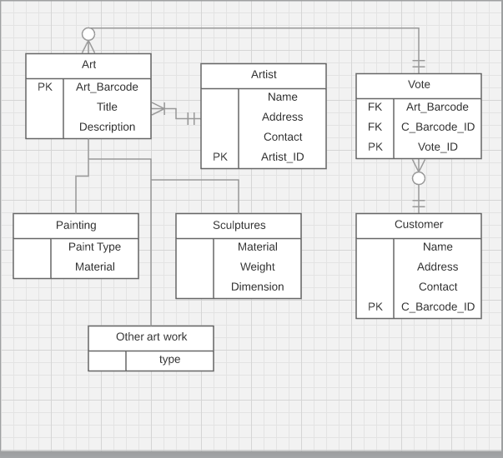

Exercise 3:

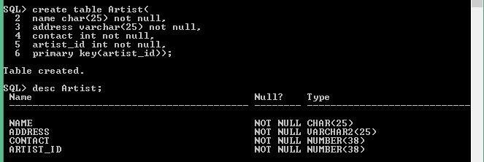

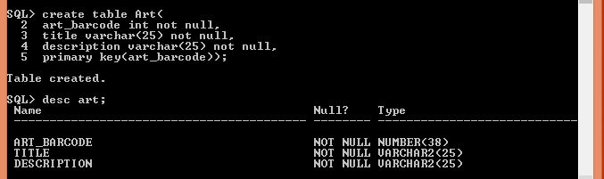

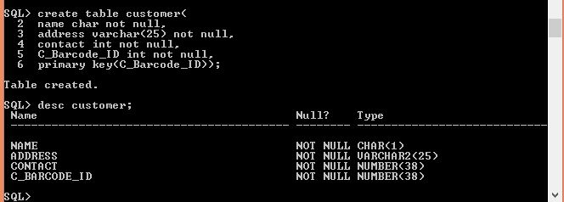

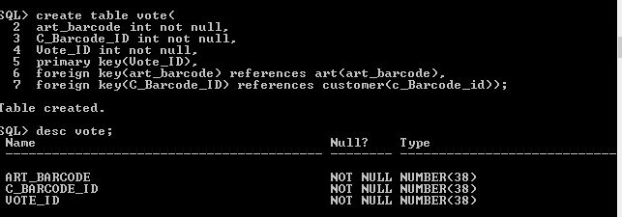

Ques2:

Exercise 1:



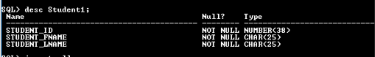

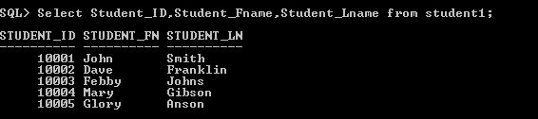

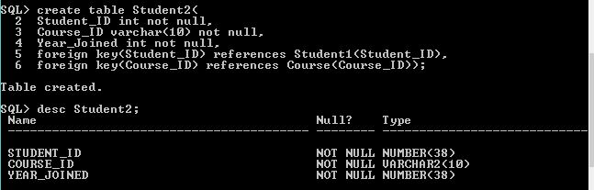

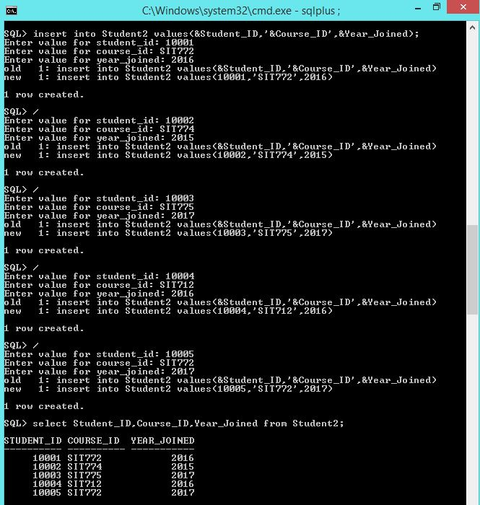

 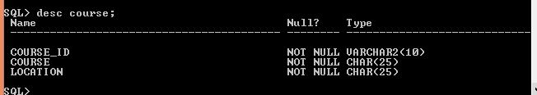

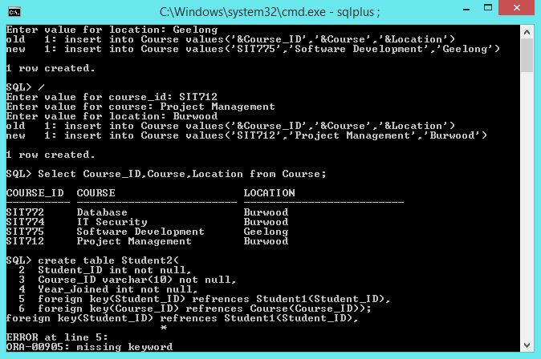

Exercise 2:

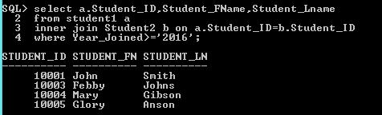

Exercise 3:

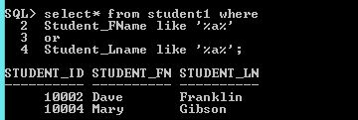

Exercise 4:

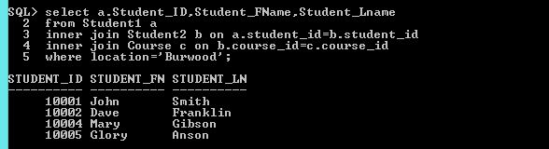

Exercise 5:

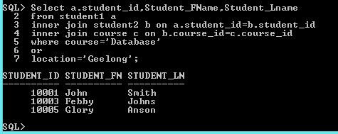

Ques3:

Exercise 1:

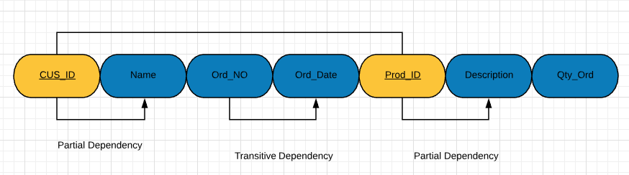

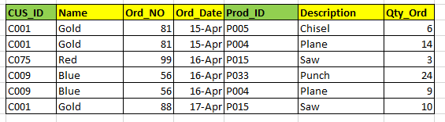

**Table Name:** Sales

**Composite Key:** CUS_ID, Prod_ID (Marked in Green)

**Relational Schema:** (**CUS_ID,** Name, Ord_NO, Ord_Date, **Prod_ID,** Description, Qty_Ord)

Exercise 2:

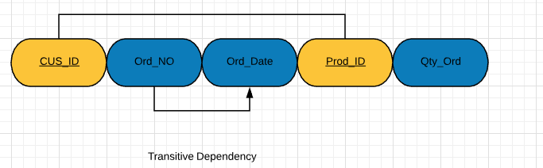

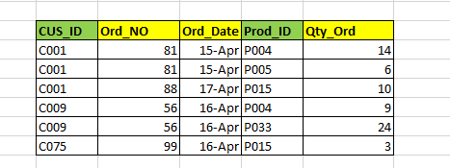

**Table Name:** Sales

**Composite Key:** CUS_ID, Prod_ID (Marked in Green)

**Relational Schema:** (**CUS_ID,** Ord_NO, Ord_Date, **Prod_ID,** Qty_Ord)

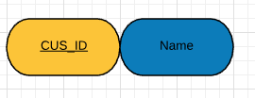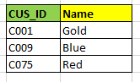

**Table Name:** Customer

**Primary Key:** CUS_ID (Marked in Green)

**Relational Schema:** (**CUS_ID,** Name)

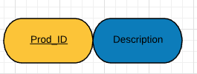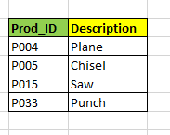

**Table Name:** Product

**Primary Key:** Prod_ID (Marked in Green)

**Relational Schema:** (**Prod_ID,** Description)

Exercise 3:

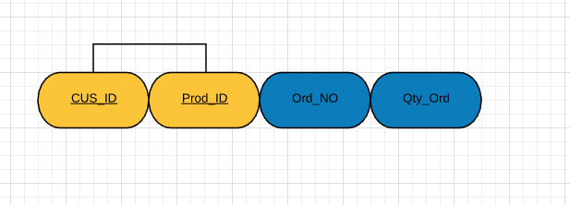

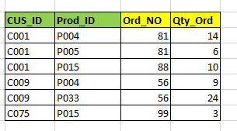

**Table Name:** Sales

**Composite Key:** CUS_ID, Prod_ID (Marked in Green)

**Foreign Key:** Ord_NO

**Relational Schema:** (**CUS_ID, PROD_ID,** ORD_NO, Qty_Ord)

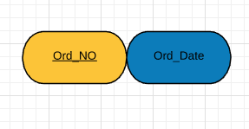

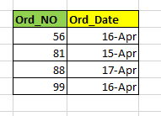

**Table Name:** Order

**Primary Key:** Ord_NO (Marked in Green)

**Relational Schema:** (**Ord_NO,** Ord_date)





**Table Name:** Customer

**Primary Key:** CUS_ID (Marked in Green)

**Relational Schema:** (**CUS_ID,** Name)





**Table Name:** Product

**Primary Key:** Prod_ID (Marked in Green)

**Relational Schema:** (**Prod_ID,** Description)

Exercise 4:

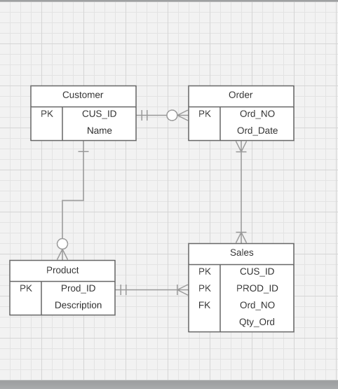

Ques4:

Exercise 1:

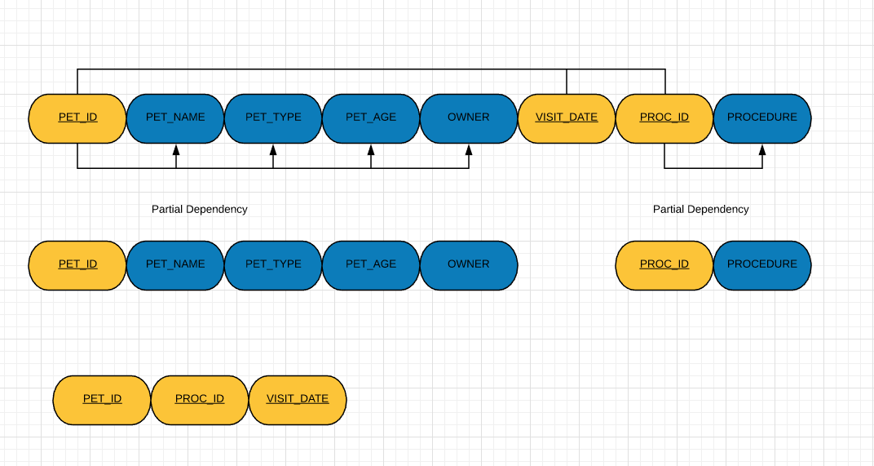

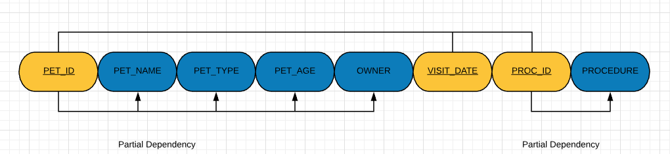

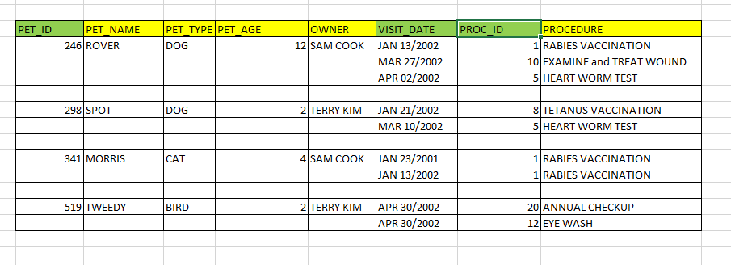

**Composite Key :**( PET_ID, PROC_ID, VISIT_DATE)

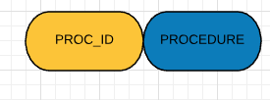

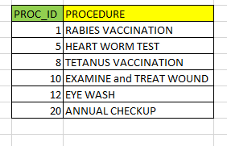

**Table Name:** Procedure

**Primary Key:** PROC_ID (Marked in Green)

**Relational Schema:** (**PROC_ID,** Procedure)

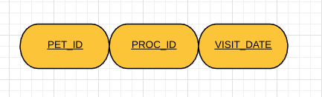

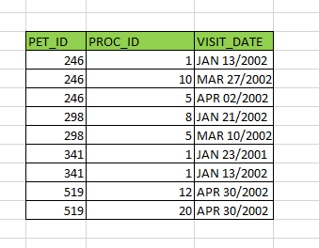

**Table Name:** Pet_Visit_Proc_Record

**Composite Key:** (Pet_ID, Proc_ID, Visit_Date) (Marked in Green)

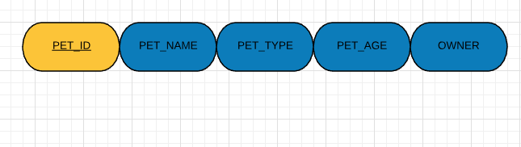

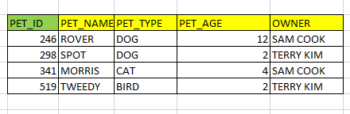

**Table Name:** Pet_Information

**Primary Key:** Pet_ID (Marked in Green)

**Relational Schema:** (**Pet_ID,** Pet_Name, Pet_Type, Pet_Age, Owner)

Exercise 2:

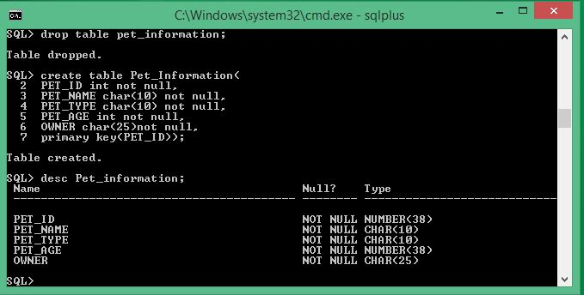

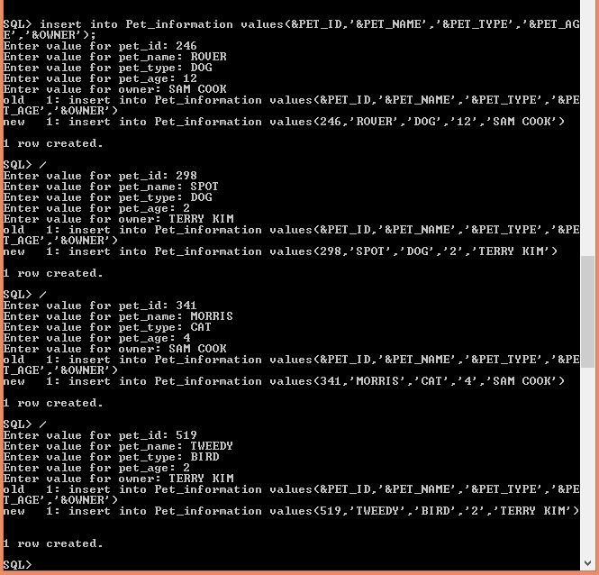

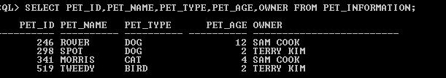

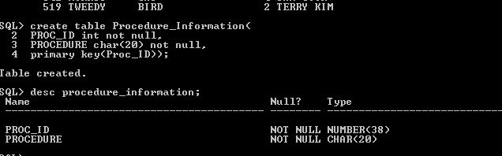

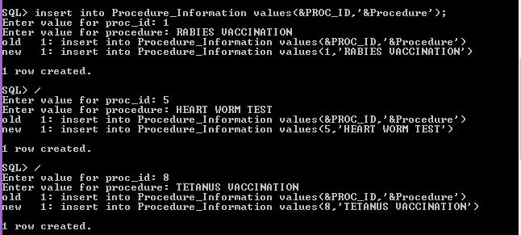

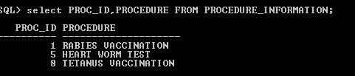

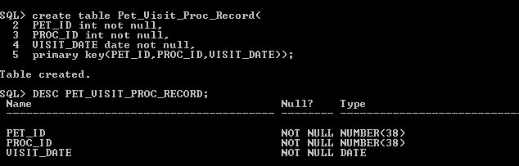

References:

1. Michael Green (2017), *Entity Relationship Diagram for Art Museum [closed],* Available at: <https://dba.stackexchange.com/questions/171909/entity-relationship-diagram-for-art-museum>

(Accessed 30 April 2018)

2-Future Learn Limited (2018), *SIT772-Database and Information Retreival*, Available at: <https://www.futurelearn.com/your-programs/database-and-information-retrieval/4>(Accessed 30 April 2018)